Welcome to CySEC Crucible
A Collectible Card Game for Cybersecurity

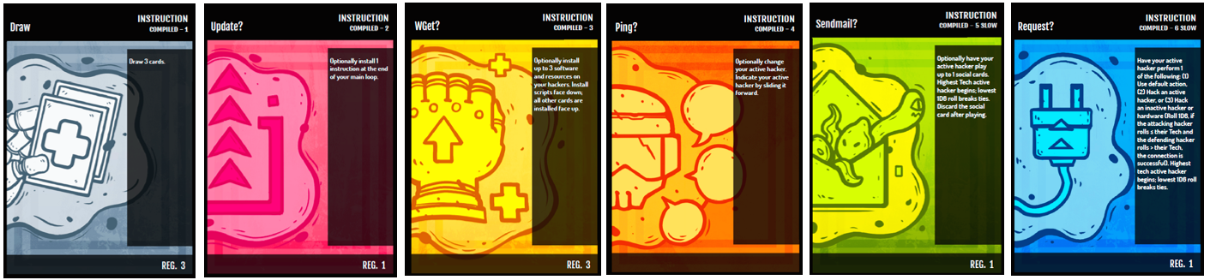

Table of Contents
Table of Contents 1
Introduction 2
Card Types 2
Hackers 2
Instructions 3
Resources 4
Software Dæmons 5
Social Hacks 6
Software Scripts 7
Game Concepts 8
Your Team 8
Credits (¤) 8
The Main Loop 9
The Cloud Deck 11
Conditions 11
Preparation 12
Game Setup 13
Gameplay Sequence 13
Hacking 14
Winning the Game 14
Losing the Game 14
Gameplay Example 15
Glossary 15

Headings from My Little Pony Card Game Instructions

Table of Contents
What you Need to Play
Collectible Card Game
The Golden Rule
The Cards (with Screen Shots
Playing the Game
Turn Order
Resolving Problems
KeyWords
Timing Rules
Number of Players
Deck Building
Other Rules
Credits

Introduction

Other hackers have started to interfere with your business — harassing or outright taking clients, consulting with your targets to improve their security, and constantly hammering your servers with garbage. Prove that you are the best hacking mastermind and clean up the competition.

Card Types

Hackers
Deniability is important, and so you perform your work through other hackers to perform hacks, social engineering, and when the time comes, go to prison while your hands stay clean. They know this, and if your team does not hear from you, they can only assume that you have been imprisoned.

Each Hacker has an Infamy rating in the upper-right of the card. Your team can have a maximum of 6 total Infamy. For example, you could have a 1-Infamy hacker and a 5-Infamy hacker, three 2-Infamy hackers, or even one 6-Infamy hacker. All hackers on your team must have unique names.

Hackers have three personal statistics (Tech, Talk, and Data) and three statistics for their computer rig (CPU, Mem, and I/O). Larger numbers are better in all cases.

Tech shows the hacker's technical skill and is used for acting quickly, starting hacks with inactive hackers, and executing difficult programs. Talk indicates the hacker's skill with social engineering, creating emails that encourage people to execute hidden code within them. Data shows the amount of incriminating data required to send a hacker to prison. When this data is collected by opposing hackers, it is immediately made public. If a hacker's secret Data is reduced to zero, then they are arrested and can no longer be used in the game.

CPU shows how many scripts a hacker can execute during a hack, while Mem indicates the maximum amount of software they can install on their rig. I/O (short for Input/Output speed) is how fast the rig's network connection is and how fast their scripts execute remotely.

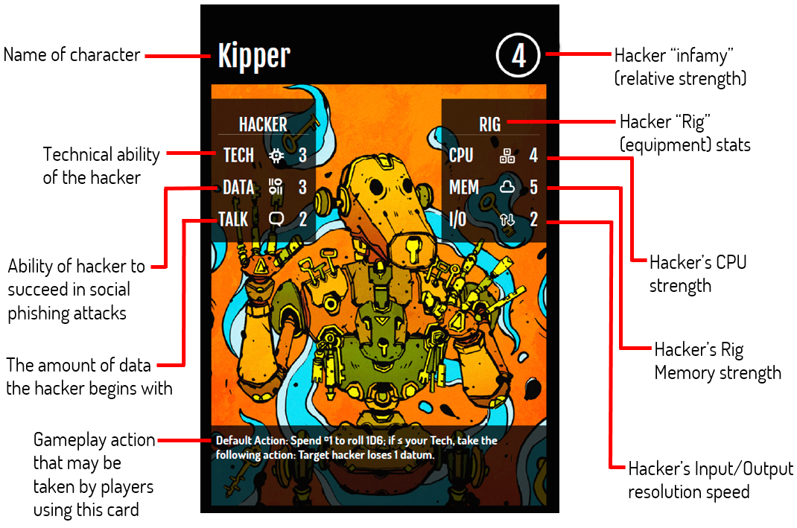

Instructions
There are three kinds of instruction cards, Compiled, Interpreted, and Patches. Compiled cards remain in the loop and may have variables or registers that determine how they are used. Use the values in the registers (abbreviated reg.) wherever the name is denoted by brackets [ ] in the rule text. Interpreted cards take effect when executed and are then discarded. Patches modify registers on compiled cards; place them underneath the affected register so the Register ∂ (delta) lines up with the affected register.

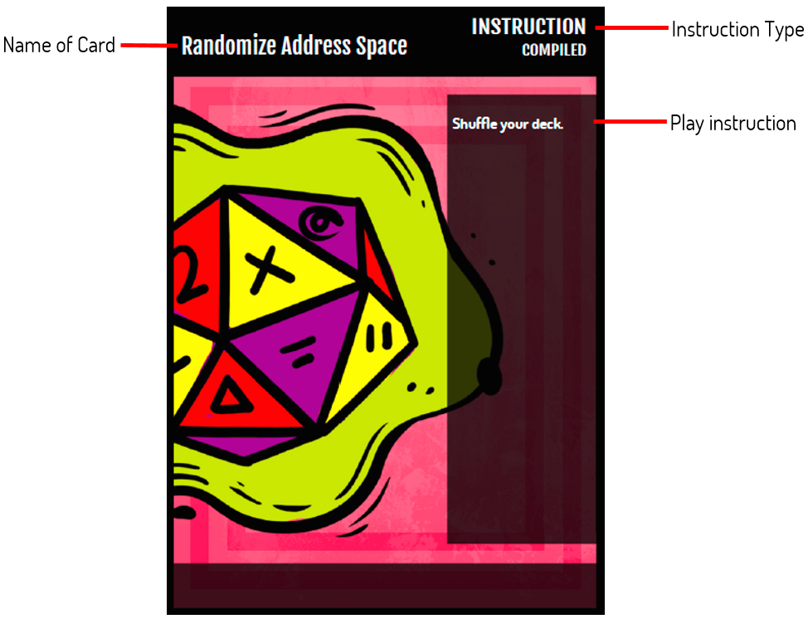

Resources
Resources indicate physical Hardware, Services, and Training that you provide to your hackers. Resources generally cost Credits (¤). Resources with a Tech and Data statistics may also be hacked as if they were inactive hackers; if they lose data equal to their Data statistic, the card is discarded.
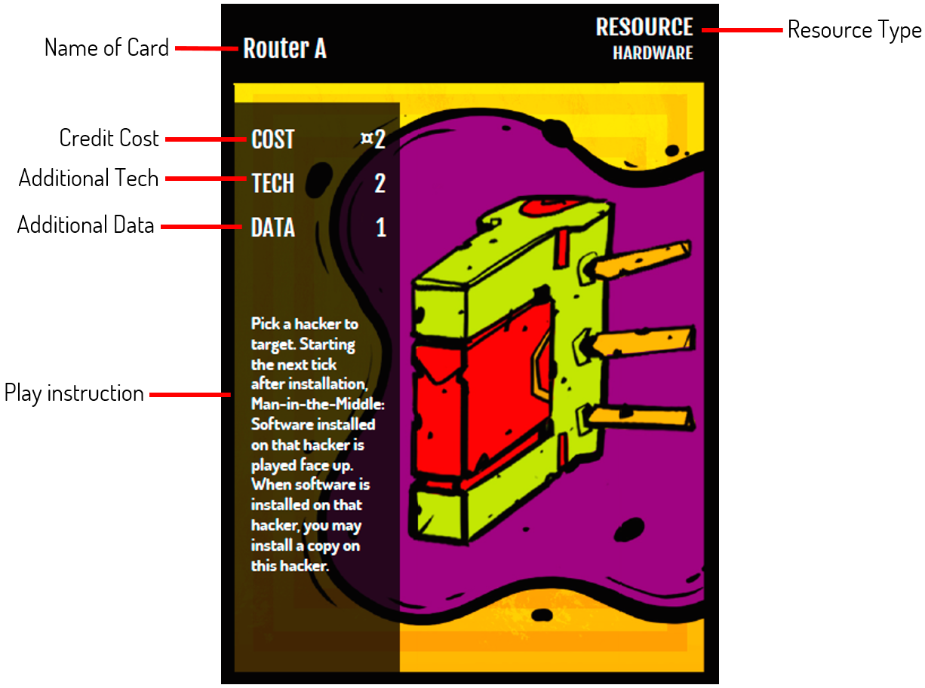

Software Dæmons
Dæmons are software that generally provide passive effects. As each one runs continuously on the hacker's rig, they may affect the rig's base CPU and I/O, and each dæmon can consume a varied amount of Mem. Dæmons also include Malware, such as viruses that your hackers can install on opposing hackers' rigs using other cards.

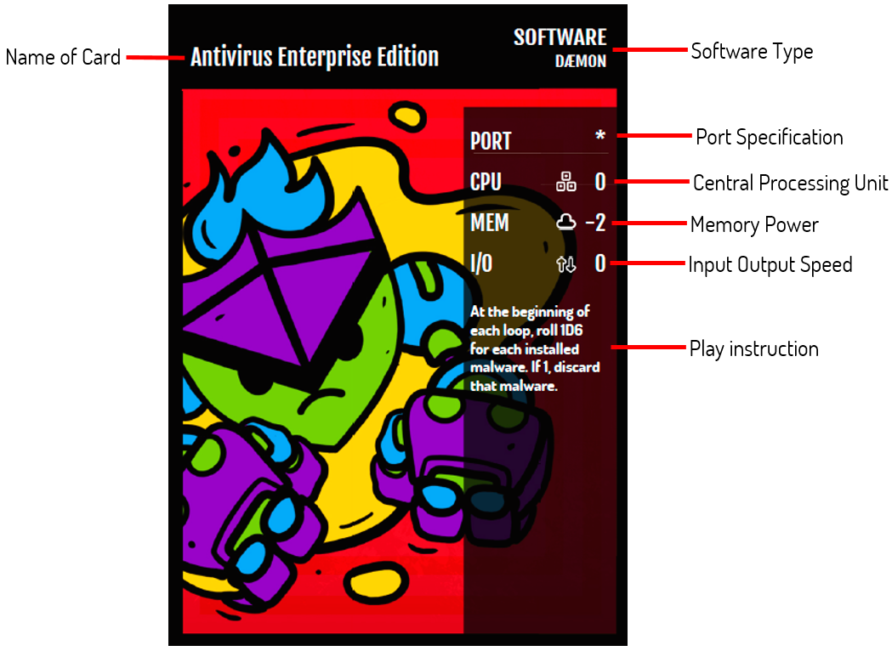

Social Hacks
Social Engineering cards, abbreviated as Social, are attempts by your hackers to use email, text messaging, phone calls, and other communication methods to coerce others. Phishing works against the general public, while Spear Phishing cards target opposing hackers. Whaling cards either target an opposing player or require greater risks and resources for larger payoffs. Social cards may have a cost in Credits, located in the upper-right.

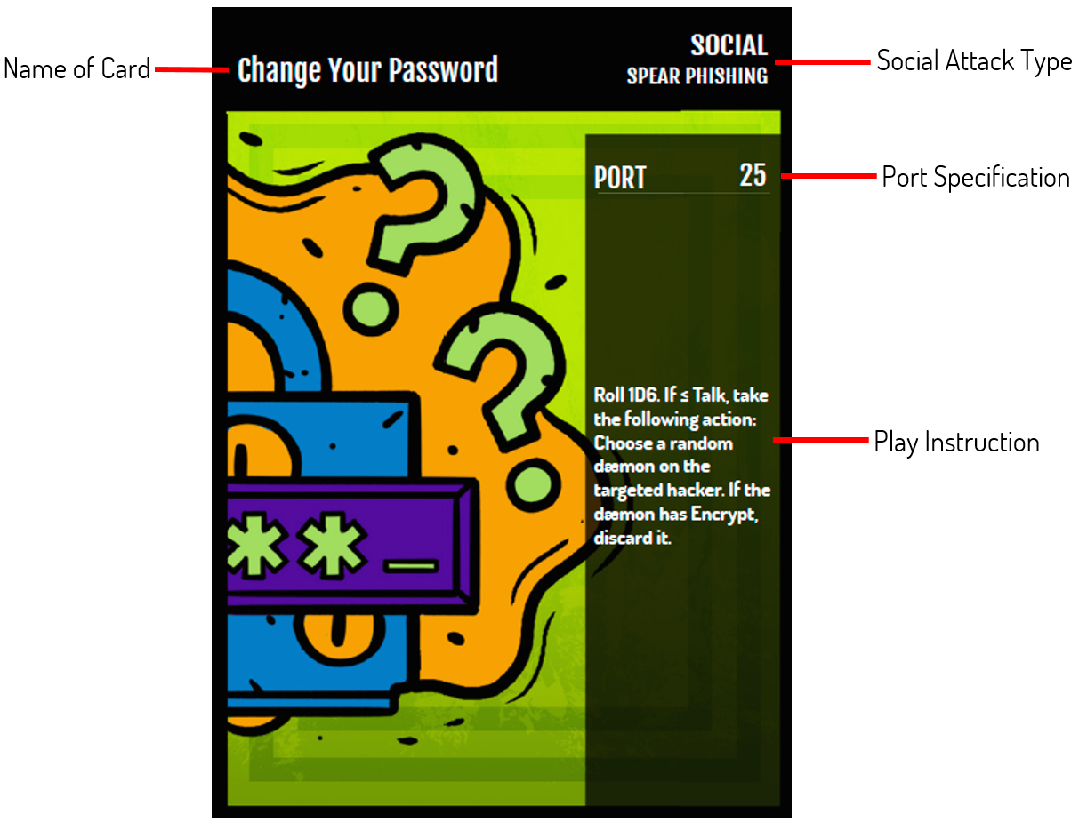

Software Scripts
Scripts are software your hackers use when hacking and being hacked. Scripts are installed facedown on a hacker, and each one requires 1 Mem from the Rig. Each Script additionally consumes CPU cycles during a hack and resolves with its I/O speed plus any other I/O modifiers.
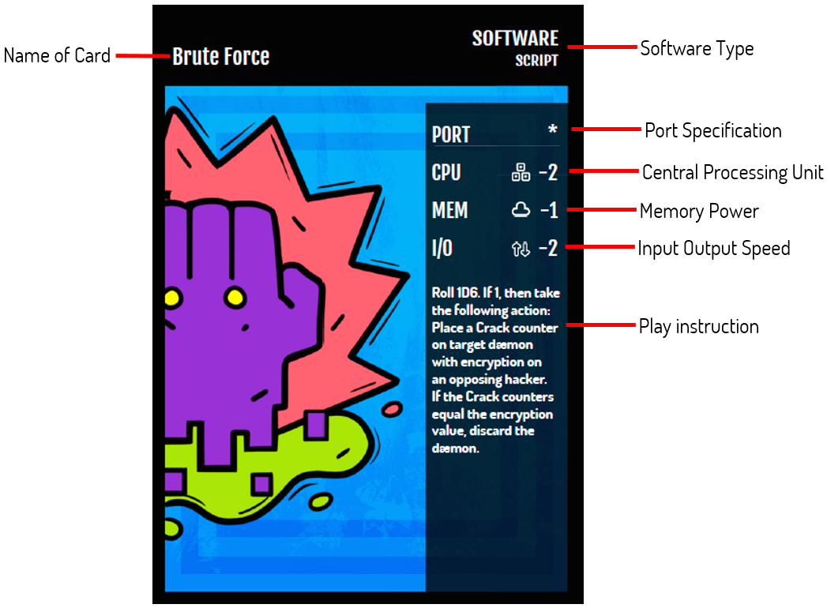

Game Concepts

Your Team
In your team of hackers, one is the Active Hacker while the others are Inactive Hackers. Active Hackers are the ones who play Social cards, hack other Active Hackers, or attempt to hack Inactive Hackers or Resources with a Tech statistic.

You lose the game if all of your hackers are imprisoned (other players have collected data equal to their Data statistic) or if your active hacker becomes imprisoned and you have no way to make another hacker active.

Credits (¤)
Each player begins with six (6) credits (¤). Use a six-sided die to represent your current credits. You may gain more than 6¤, but you cannot have negative credits. Credits are used to purchase resources and some software dæmons.

The Main Loop
The Main Loop is the program you use to coordinate and support your hacking team. Each player's initial main loop starts with the same instructions in the same order: Draw, Update?,

WGet?, Ping?, Sendmail?, and Request? in that order. The current instruction is indicated using an Instruction Pointer (IP). Use your credits die as the IP, placing it on Draw at the beginning of the game.

The time spent executing an instruction is called a tick. At the start of a new tick, players perform the actions on the instruction card indicated by the instruction pointer (IP). After all players have finished executing their actions, the tick ends and players move their IP to the next instruction to the right. If there are no other instructions in the main loop, the player places the IP on their leftmost instruction card, performs any actions with New loop:, and then executes its actions.

A new tick begins. Bob's IP is on the last instruction in his main loop, an Increment patch instruction. He decides to increment register A on his Draw instruction, making it so he'll draw 4 cards when it's executed instead of 3. He places the Increment card underneath his Draw instruction so the Reg. ∂ lines up with Reg. A. At the end of the tick, there are no instructions to the right of his IP, and so he returns it to the first card in his main loop, Draw. One of his hackers has a Virus C installed with a New Loop condition, and so he rolls to see if he needs to discard a card. He gets a 5, and so he's safe for now. He continues the tick by executing his newly-incremented Draw card.

When multiple hackers are acting based on an instruction (e.g., if one player is executing Sendmail? and two others are executing Request?), the active hacker with the highest Tech acts first. If there is a tie, each player rolls 1D6 with the lowest result acting first. Instructions with slow always execute after instructions without slow.

As the tick begins, Alice's IP is on Sendmail? and Bob's IP is on Draw. Sendmail? is slow, and so Bob draws his cards. Alice then has her active hacker play an Account Upgrade card from her hand.

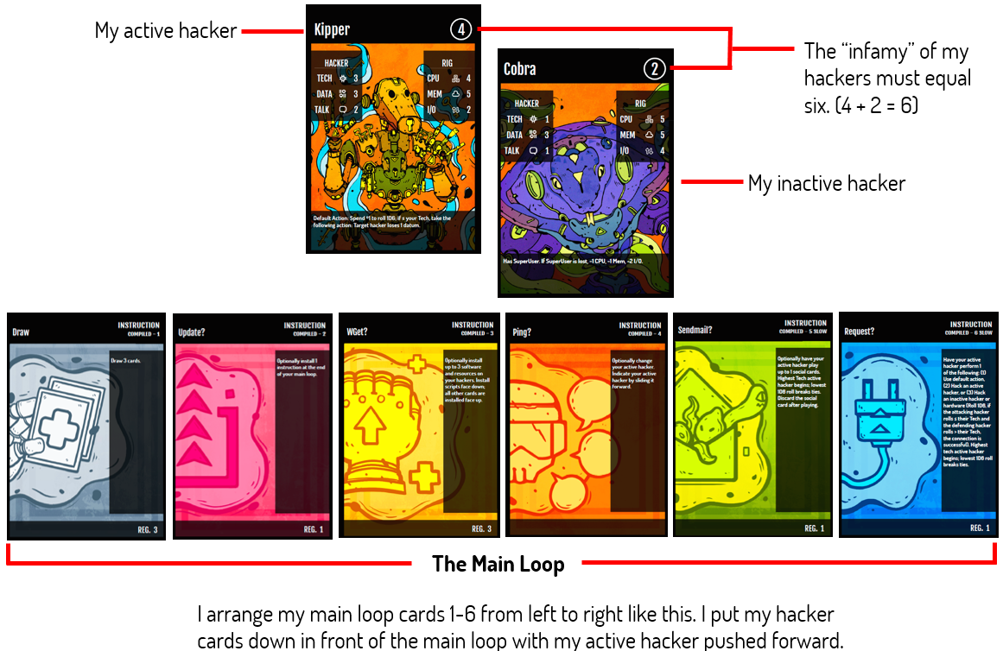

The Cloud Deck
The Cloud Deck consists of at least 40 cards with no more than 4 copies of each card. Your team of hackers and initial main loop cards do not count toward the 40 cards; however, your main loop cards are considered toward the maximum of 4 copies of each card. Customize this with the additional Instructions, Resources, Software, and Social cards to achieve your strategy to win. Your Cloud Deck may not include additional hackers. You begin the game by drawing 6 cards from your Cloud Deck.

You lose the game if you must draw a card from the Cloud Deck and are unable to.

Conditions
Card rules may require die rolls to determine whether or not they succeed. These are
conditions.

Test S N means to roll N six-sided dice and continue if all dice are ≤ statistic S. So Test Talk 2 means roll 2 six-sided dice; if both are less than or equal to the active hacker's Talk statistic, the action succeeds. The number on the die is placed in the result register, and cards may refer to the value by using brackets: [result].

During a hack, Alice uses Alpha to play Memory Scan, which requires a Test Tech 1 roll. She rolls a six-sided die and gets a 2—a success given the hacker's Tech of 2. The result register is equal to the result of her roll, 2, and so she looks at the top 2 cards of Bob's Cloud deck.

Contest S0 N0/S1 N1 is a set of two tests, one for the acting hacker (Test S0 N0) and one for the target hacker (Test S1 N1). The action only succeeds if the acting hacker passes the test and the target hacker fails the test.

Bob's active hacker is Eta with a Tech of 2, and he's trying to hack Alice's inactive hacker Gamma with a Tech of 1. Attempting to hack an inactive hacker requires a Contest Tech 1/Tech 1: For Bob's hacking attempt to succeed, he must successfully Test Tech 1 by rolling 1D6 and getting ≤ Eta's Tech of 2 and Alice must fail a Test Tech 1 by rolling 1D6 and getting > Gamma's Tech of 1.

Fail N means to roll N six-sided dice and to continue with the following action if any die is a six (6).

Bob has a hacker with a Virus C installed. When he returns to the start of his main loop, it triggers the Virus C's New Loop condition with a Fail 1 test. He rolls 1D6 and gets a 6! He then discards a card from his hand as directed by the Virus C card.

Check N means to roll N six-sided dice and continue with the following action if all dice are ones (1).

Alice has a hacker with an Antivirus Free Edition installed, and a Worm from an adjacent hacker has just spread. This triggers the Antivirus's "When new malware is installed" rule with a Check 1 condition. She rolls 1D6 and rolls a 2. The Check fails, and so the worm stays installed. If she had rolled a 1, then the Antivirus would have discarded the Worm.

Preparation
Success requires careful preparation before starting the game. Do you plan to steal incriminating data from opposing hackers to imprison them? Use social engineering to coerce them to do your bidding? Implant malware leading them to self-destruct? Deciding how you want to win will influence how you construct your team and your deck.

After deciding on a strategy, select a team of hackers with a total infamy of 6. Hackers on your team must have unique names. Choose hackers that can help you realize your winning strategy. Also set aside one card each of Draw, Update?, WGet?, Ping?, Sendmail?, and Request?. These cards will comprise your initial main loop.

Finally, create your Cloud deck of at least 40 cards. These cards do not include your team of hackers or your initial main loop's instruction cards. Your deck may have a maximum of 4 of the same card, and your initial main loop's instruction cards do count toward the maximum number of each you may have. The Cloud deck may not contain hackers, but may contain any other type of card.

Game Setup
- Arrange the main loop of Draw →Update? → WGet? → Ping? → Sendmail? → Request?.
- Place your hackers in line in front of loop. Note that their ordering matters!
- Set the credits (¤) die to 6 and place it on your Draw card.
- Shuffle your Cloud deck.
- Optionally cut an opponent's Cloud deck.
- Draw 6 cards.

Gameplay Sequence
Players execute their loops from synchronously from left-to-right. After all players have resolved their instructions, they advance they IP to the next instruction and continue. If there are no other instruction cards, return the IP to the first instruction card on the left, perform any "Before executing…" actions, and then continue executing the instruction. Slow instruction cards execute after other instructions have executed.

At the start of the game, Alice and Bob place their credits die on Draw as their instruction pointer (IP). Both draw three cards since Reg. A on Draw is currently three, for a total of nine cards in their hands. Both have executed their instructions, and so they move their die to Update?. Alice installs Peek at the end of her main loop, while Bob chooses not to install any instructions.

Later, Alice and Bob have just finished executing their Request? instructions. Alice advances her IP to Peek and looks at the top three cards of her Cloud deck. Meanwhile, Bob returns his IP to Draw, performs any "Before executing…" actions, and then proceeds to draw three cards.

All installed software and some installed resources have a Rig Mem cost. If the sum of the Rig's Mem and installed software and resources is less than or equal (≤) to 0, the hacker's owner must discard non-malware software or resources before advancing to the next instruction until the sum is ≥ 0.

Hacking
Each player in a Hack collects the installed scripts on their hacker and holds them in their hand. You may replay installed scripts.

- The attacking hacker announces whether they are stopping the hack or continuing.
- Each player selects one script and holds it vertically by their hacker. The script CPU plus the total of previous script CPUs must be ≤ the current Rig CPU.
Alice's Nu is hacking Bob's Eta. Nu's current Rig CPU is 5. Alice elects to play Nu's Copy Logs, which has a CPU of -2, leaving 3 CPU for future scripts during this hack. Alice will be able to play Copy Logs again… unless Eta does something to prevent it.

- After all scripts are being held vertically, each player announces a target hacker participating in the hack for their script. Announce from lowest to highest Tech, with the attacking hacker announcing first in ties.
- Simultaneously reveal scripts.
- Determine the Total I/O for each script: the total is the current Rig I/O + Script I/O. The highest I/O resolves first; ties resolve simultaneously.
Alice's Nu played Copy Logs and has no other software installed. The Total I/O for this is Nu's current Rig I/O of 2 + Copy Log's I/O of 0 or 2 total. Bob's Eta revealed an Undelete script. Eta also has Autoupdate installed. The Total I/O for Eta is then the current Rig I/O of 2 (the default) + the installed Autoupdate's I/O of
-3 + Undelete's I/O of -2 for a total of -3. Since Nu's Total I/O of 2 is greater than Eta's I/O of -3, Copy Logs resolves before Undelete.

- A hacker with their secret data reduced to zero (0) becomes incarcerated: discard all attached cards and turn them face-down.
- The attacker may elect to continue the attack from step 1 or stop the hack.

Winning the Game
Be the last player with hackers out of prison.

Losing the Game
You lose the game if

You have no hackers outside of prison.
You must draw a card and cannot.
You are unable to select a new hacker within one complete execution of your main loop and your active hacker is incarcerated.

Gameplay Example
TO DO.

Glossary

Check N
Check means to roll N six-sided dice and take the following action if all dice are ones (1).

Cloud Deck
The deck of instructions, resources, social, and software script and dæmon cards.

Contest S0 N0/S1 N1
Contest is a set of two tests, one for the acting hacker (Test S0 N0) and one for the target hacker (Test S1 N1). The action only succeeds if the acting hacker passes the test and the target hacker fails the test.

CPU
A rig's processing power. Each script played during a hack requires CPU, and the total CPU usage must be less than the rig's CPU.

D6
A six-sided die. The abbreviation XD6 means to roll X six-sided dice: 1D6 is one six-sided die, while 3D6 is three six-sided dice.

Encrypt X
Hackers with Encrypt cards installed are immune to evidence loss. The X indicates the encryption amount.

Evidence
Each hacker starts with an evidence of 0. When evidence equals their legal stat, they become incarcerated and unable to take new actions or be an active hacker. If a player is unable to choose an active hacker and their active hacker becomes incarcerated, they lose.

Fail N
Roll ND6. If any die is a 6, take the following action.

Hacker
A skilled cyber security technologist working for players.

Infamy
Located on the upper-right of hacker cards. Higher infamy means the hacker has a greater reputation—and skills—as a hacker. The total infamy of a team must equal 6.

Instruction
A command executed on the player's rig. Each instruction executes simultaneously for all players.

Install
Playing a resource, social, or software card. Scripts and Social cards are played face-down; other cards are played face-up.

I/O
Input/output. The sum indicates how quickly a script executes during a hack, with higher numbers being faster.

Legal
Indicates legal connections, favors, and the amount of evidence required to incarcerate a hacker.

Main Loop
A sequence of instruction cards

Man-in-the-Middle
Require a target. Man-in-the-middle allows a player to view newly installed software

Mem
A rig's memory. Limits the amount of software that can be installed.

Personal
Used by the Player; these cards are installed directly in front of the player and behind the main loop.

Port Number
A number indicating a communication channel.

Register
A variable used by instructions: Use the value of the register as specified in the instruction rule.

Rig
A hacker's computer.

Social
A social engineering attempt.

Software Dæmon
A program that runs continuously, providing passive effects.

Software Script
A program used during a hacking attempt.

Super User (SU)
A user account with increased privileges.

Talk
Skill at social engineering.

Tech
Skill with using computers and technology.

Test S N
Roll N six-sided dice and continue if all dice are ≤ statistic S. So Test Talk 2 means roll 2 six- sided dice; if both are less than or equal to the active hacker's Talk statistic, the action succeeds.

